Mouhammadou Dabo

February 18, 2021

CS 1675: Intro to Machine Learning

Professor Milos Hauskrecht

Problem Assignment 3

**Problem 1. Multivariate Gaussian**

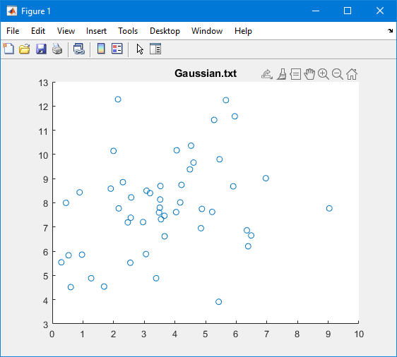

**Scatter plot of the data “gaussian.txt.”**

**ML estimate of Mean** = [$\begin{matrix}3.6377 & 7.8506\end{matrix}$]

**Covariance Matrix** = $\left[\begin{matrix}3.6414 & 1.0779 \\ 1.0779 & 3.7831\end{matrix}\right]$

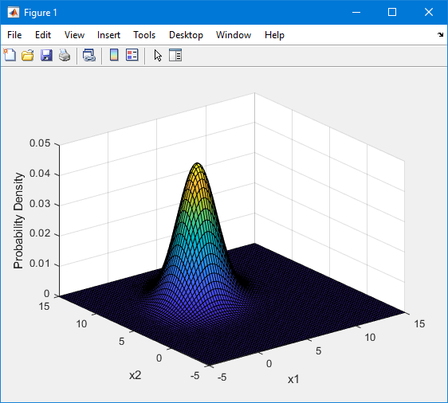

**Resulting Gaussian distribution**

**Column 1 - Mean:** 3.6377, **Variance**: 3.6414

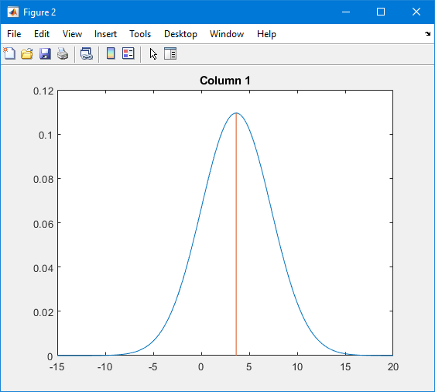

**Column 2 - Mean:** 7.8506, **Variance:** 3.7831

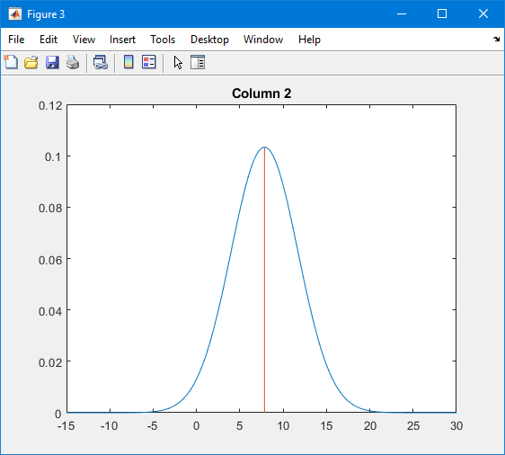

I do believe the multivariate Gaussian model is better than the two separate univariate Gaussian models. Multivariate model provides a correlation between the pair of variables and also shows the probability density. By looking at our multivariate Gaussian model you can see that the peak centers around the mean and due to the narrower tails, the plot has smaller variances.

**Problem 2. Poisson distribution**

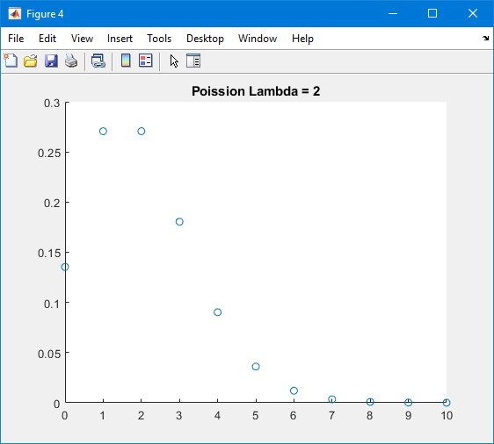

**Poisson distribution for Lambda = 2**

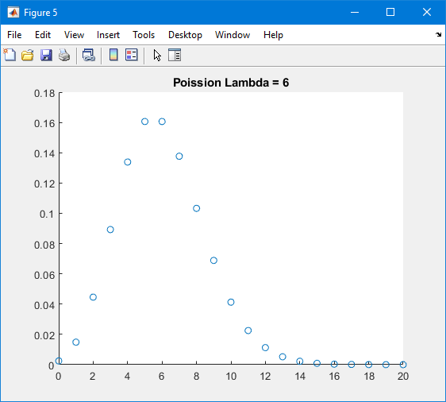

**Poisson distribution for Lambda = 6**

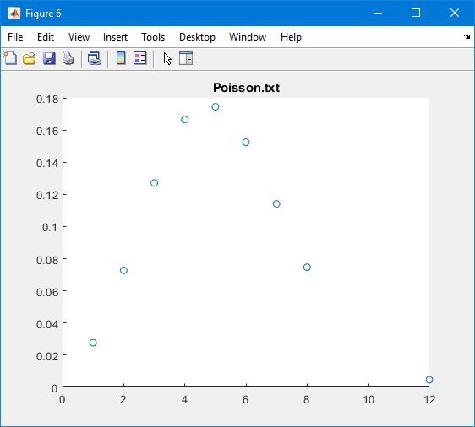

**Poisson distribution of ML parameter**

**ML estimate of Lambda** = 5.2400

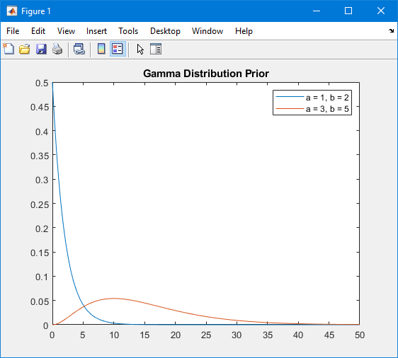

**Gamma Distribution Prior for a = 1, b = 2 and a = 3, b = 5**

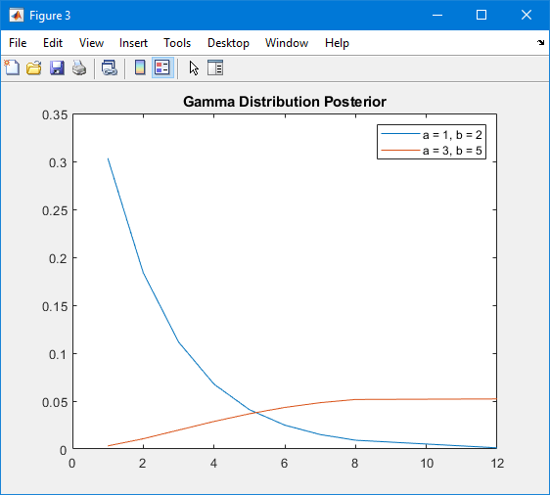

**Gamma Distribution Posterior for a = 1, b = 2 and a = 3, b = 5**

**Problem 3. Non-parametric density estimation**

**Part 1.**

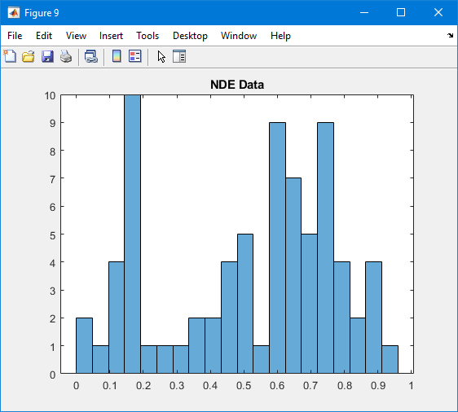

**Histogram of “NDE_data.txt”**

**Part 2.**

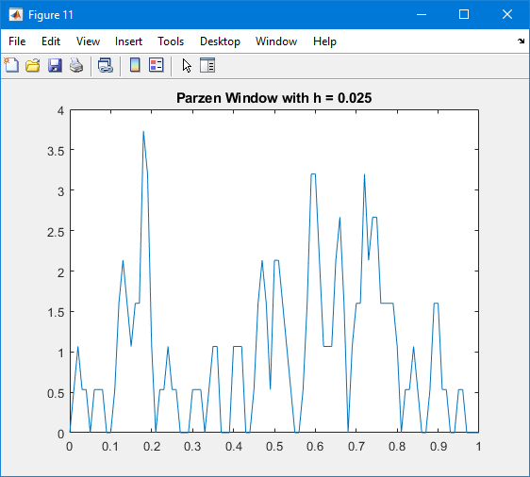

**Parzen Window with h = 0.025**

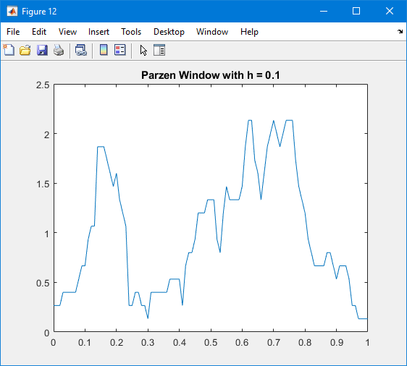

**Parzen Window with h = 0.1**

The estimates for the testing data instances Since the window size for the second graph (h = 0.1) allows more values to be accounted, resulting in a smoother curve. For the first graph (h = 0.025) the graph features more peaks, meaning there are smaller standard deviations.

**Part 3.**

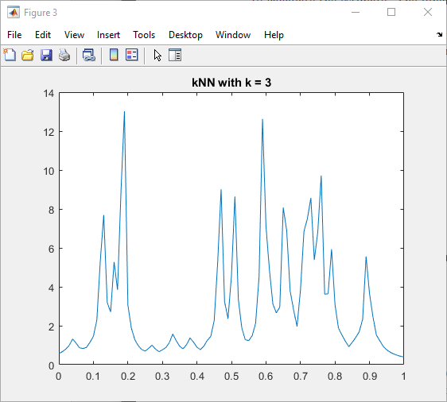

**kNN with k = 3**

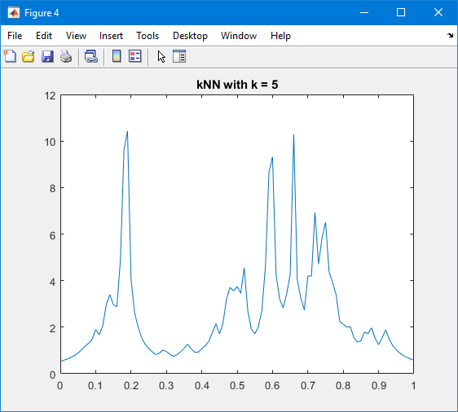

**kNN with k = 5**

The first graph (k = 3) features more peaks than the second graph (k = 5). With the second graph, with more values being accounted for with k, the graph is smoother than the first.